# Chinook ER diagram

CHINOOK DATABASE

Overview

Total Invoices :

2240

Number of customers :

59

Number of employees : 8

Number of artist :

275

1. Sales Trend :

By Year

By Month

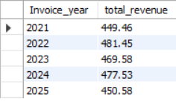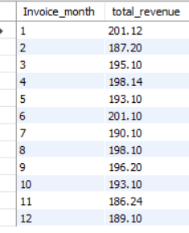

* What is the total revenue, and how is it distributed by year/month?
* Total Revenue = $2328.60

1. Top Performers :

Who are the top 10 customers by total spending?

Which 5 artists generated the most revenue?

Which music genre has the most tracks sold?

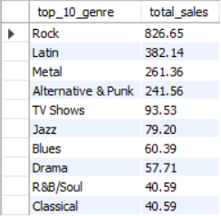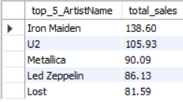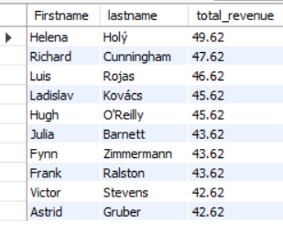

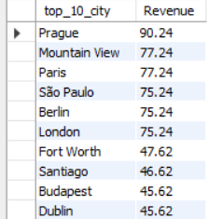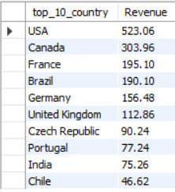

By City

Which countries/cities generate the most revenue?

1. Regional Insights :

By Country

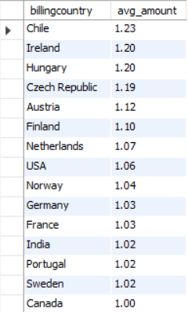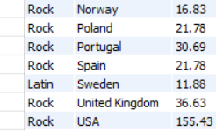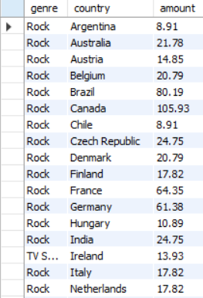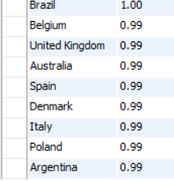 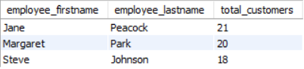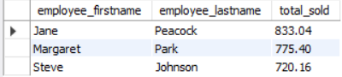

1. Detailed Intermediate Questions :

* Average Invoice Amount per Country :
* Top Selling Genre by Country :
* What’s the average invoice value?
* $5.65
* How many tracks does an average album have?
* 10
* Tracks that never sold
* 1519

Best-performing sales agents

Based on Total Sales

Based on Total Customers Attained

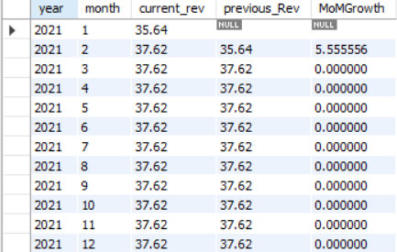

* Longest Track(s):

(Complete record can be found when ran on SQL)

* Monthly Revenue Growth :

1. Detailed Advance Questions :

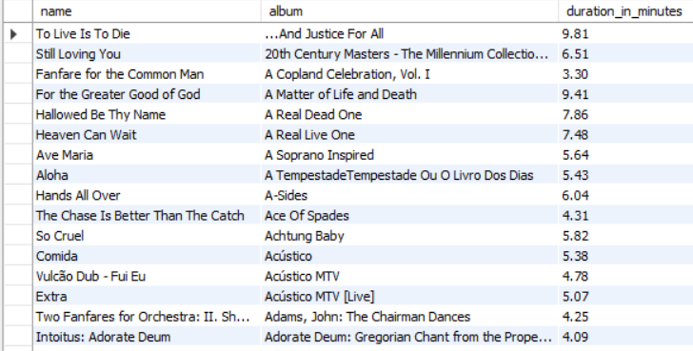

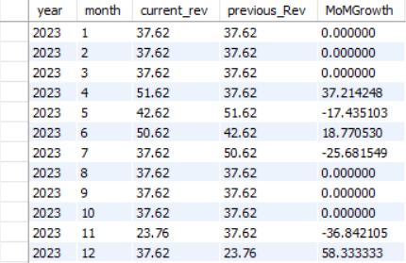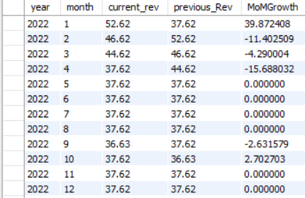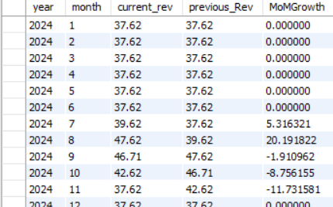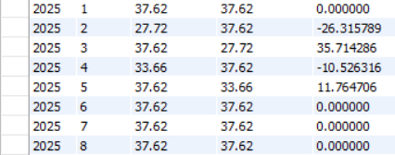 SFSSFS

ASS

* Best Customer per Genre :

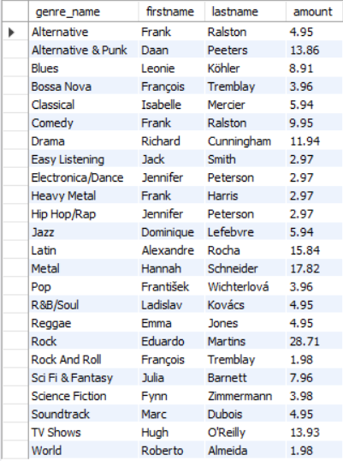

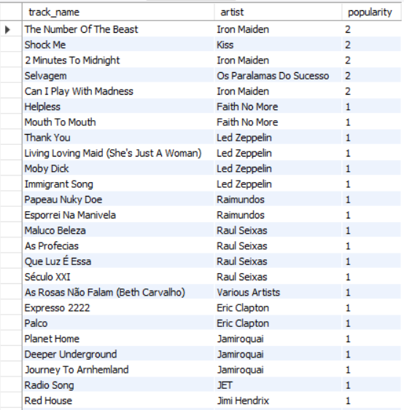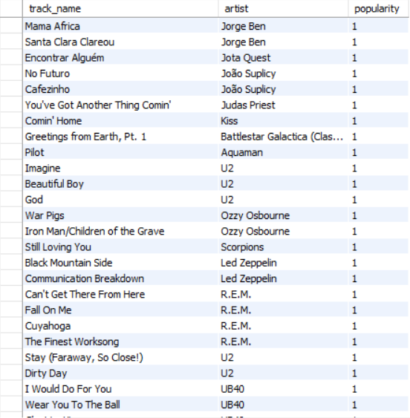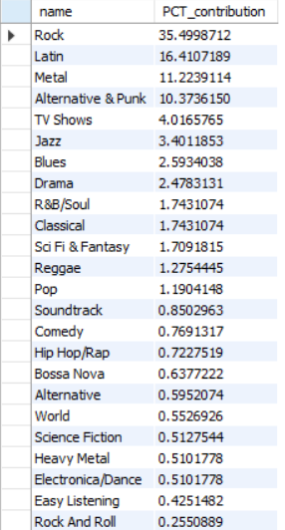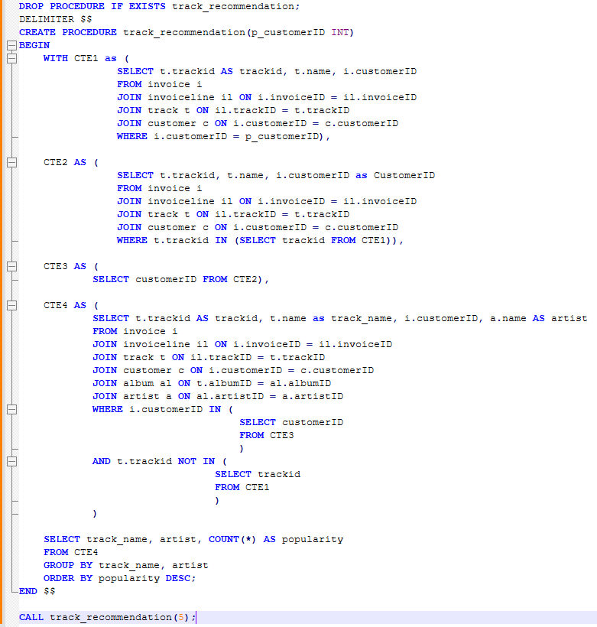

Visible are Top few records, Complete record available on SQL

* Percentage Contribution of Genres :
* Track Recommendations :

Result :